Adding Slides to the Multimedia Gallery in the School Homepage

The perfect size for the MMG is 1500 px x 750 px. Other image sizes will work as long as they maintain the 2:1 ratio. Any other image measurements will result in the image being stretched and/or squashed to make it fit within the 1500 px x 750 px space.

To Build the Gallery
In Site Manager, click Homepage to edit the page.
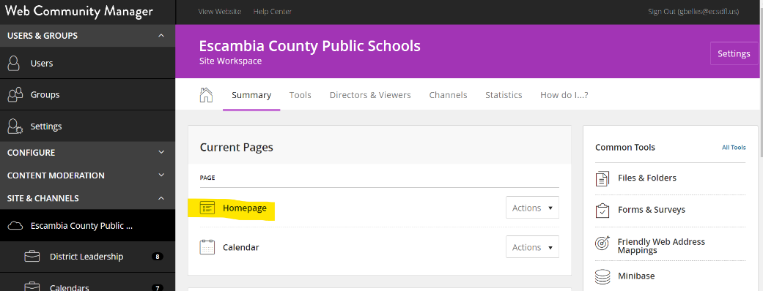

The main layout screen or “map” of your page will appear. We will be adding slides to the app in the “A” section. (It may not be labeled as shown below, but that is the app we will be using.)
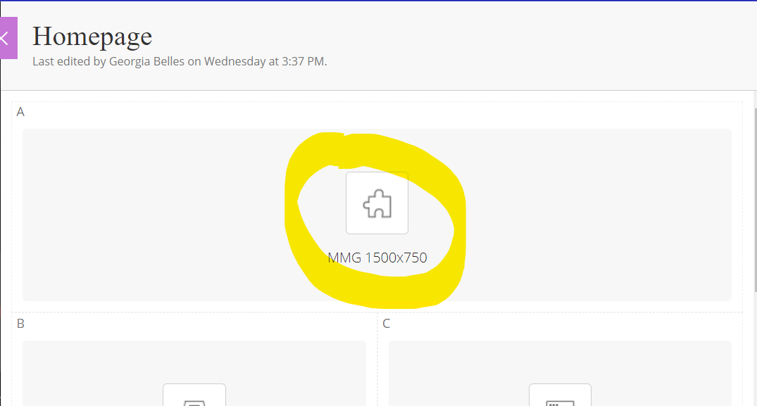

Hover over the box, then click on the green pencil icon to edit the gallery.
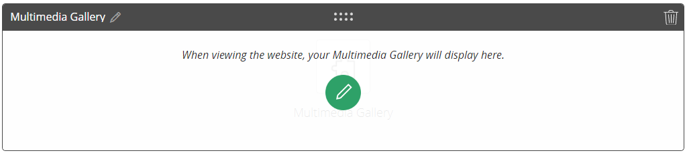

Your gallery will already have slides in it, and they will show under the STATUS area below.
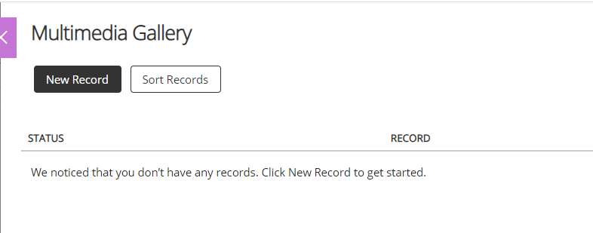
Click the black New Record button.
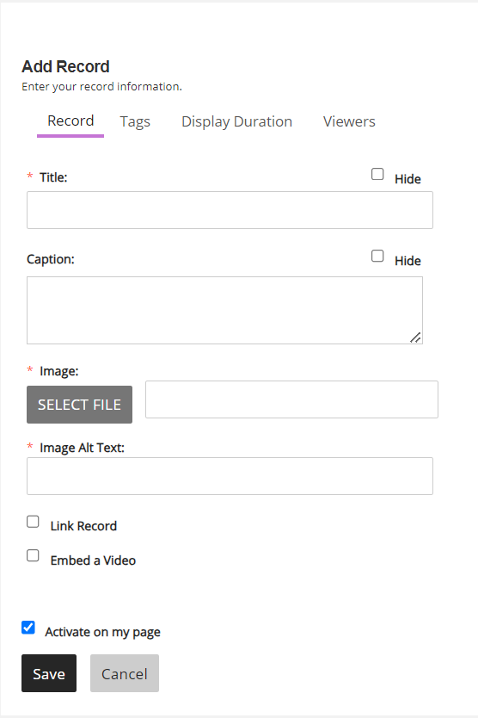
You can sort the order of your slides by choosing the Sort Records button on the app’s home pane. Hover over the gray arrows on the left side of the pane, next to the slide’s name. Click and hold on a slide’s arrows to move it up and down in the list to sort the slides.
The Add Record window appears. You are required to give each slide a title and alt text; if you don’t want the title of the slide visible on the page check the Hide checkbox across from Title.
Click Select File to upload or select the image for the slide.
Click Save.
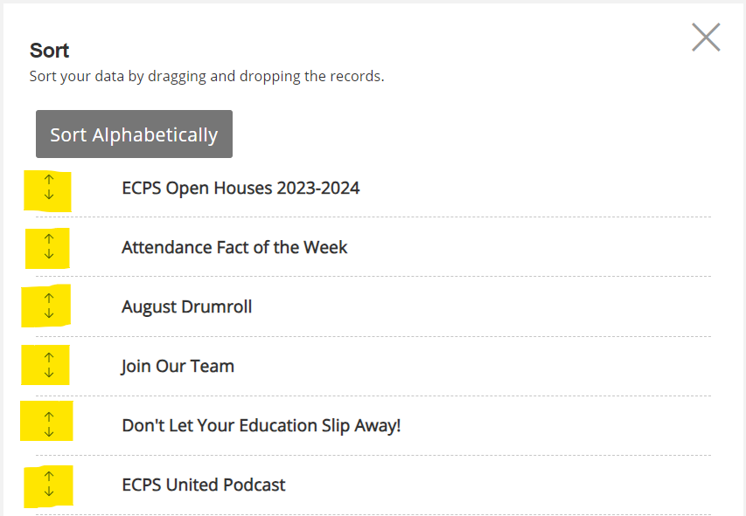

You can make a slide invisible to view but still available for future use by clicking the green ACTIVE button to switch it to INACTIVE. You also have the option to Edit the Record or Delete it (buttons not shown in the screenshot below; they are on the far right of the slide title.
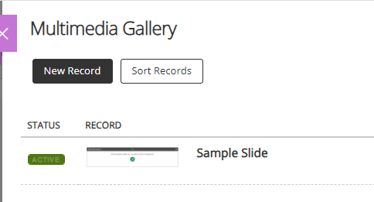
After you add your slide and click save on the Add Record screen you can exit the Multimedia Gallery app without having to save anywhere else. The app will automatically update and show the new slide among the others in your slideshow.

