Installing the Required Multimedia Gallery in the School Homepage

In order for the Global Icons to show at the top right of the school homepage a Multimedia Gallery app must be installed, even if the gallery only contains one slide (image).
The perfect size for the MMG is 1500 px x 750 px. Other image sizes will work as long as they maintain the 2:1 ratio. Any other image measurements will result in the image being stretched and/or squashed to make it fit within the 1500 px x 750 px space.

To Build the Gallery
In Site Manager, click Homepage to edit the page.
From the Apps menu, click the MMG icon and drag it to Section A of the layout, as shown below.
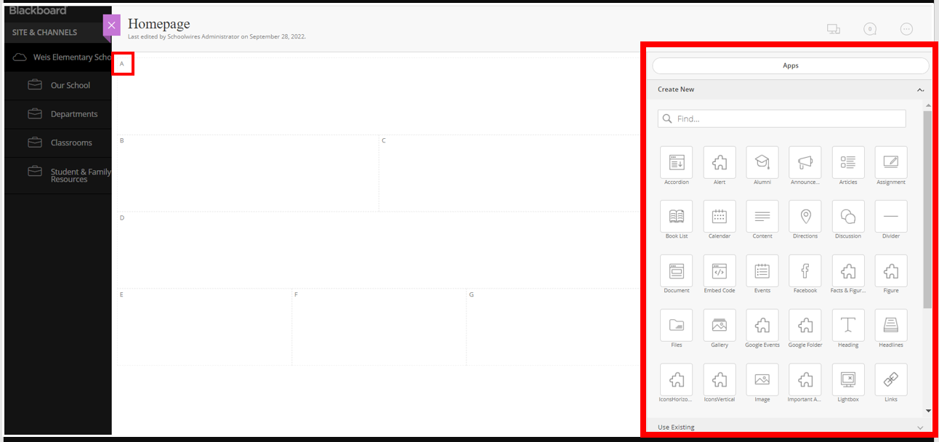

Hover over the box, then click on the green pencil icon to edit the gallery.
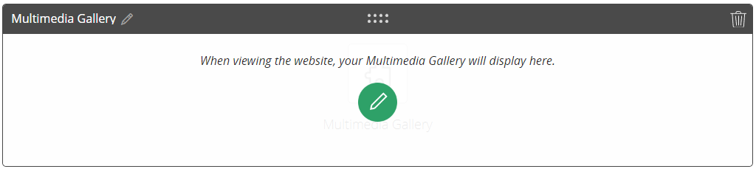

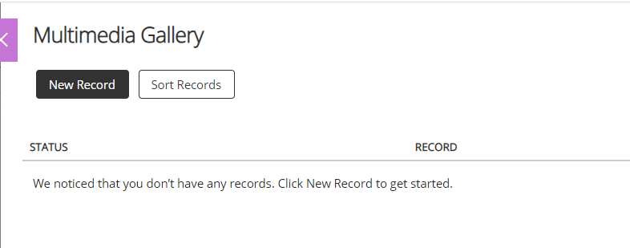
Click the black New Record button.
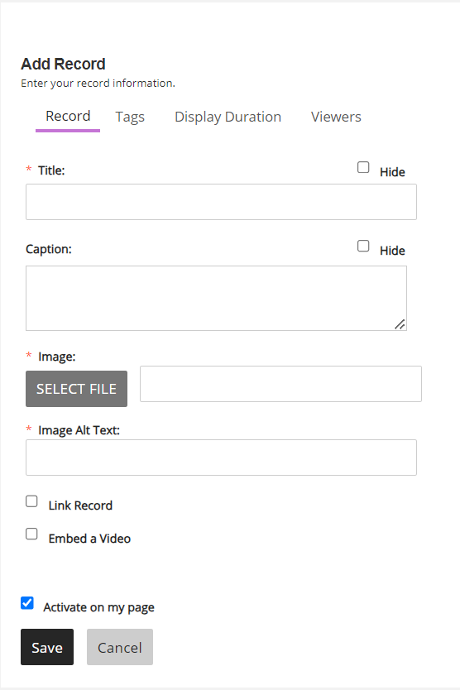
Continue adding slides in this manner. You can sort the order of your slides by choosing the Sort Records button on the app’s home pane. You can make a slide invisible to view but still available for future use by clicking the green ACTIVE button to switch it to INACTIVE. You also have the option to Edit the Record or Delete it (buttons not shown in the screenshot below; they are on the far right of the slide title.
The Add Record window appears. You are required to give each slide a title and alt text; if you don’t want the title of the slide visible on the page check the Hide checkbox across from Title.
Click Select File to upload or select the image for the slide.
Click Save.
